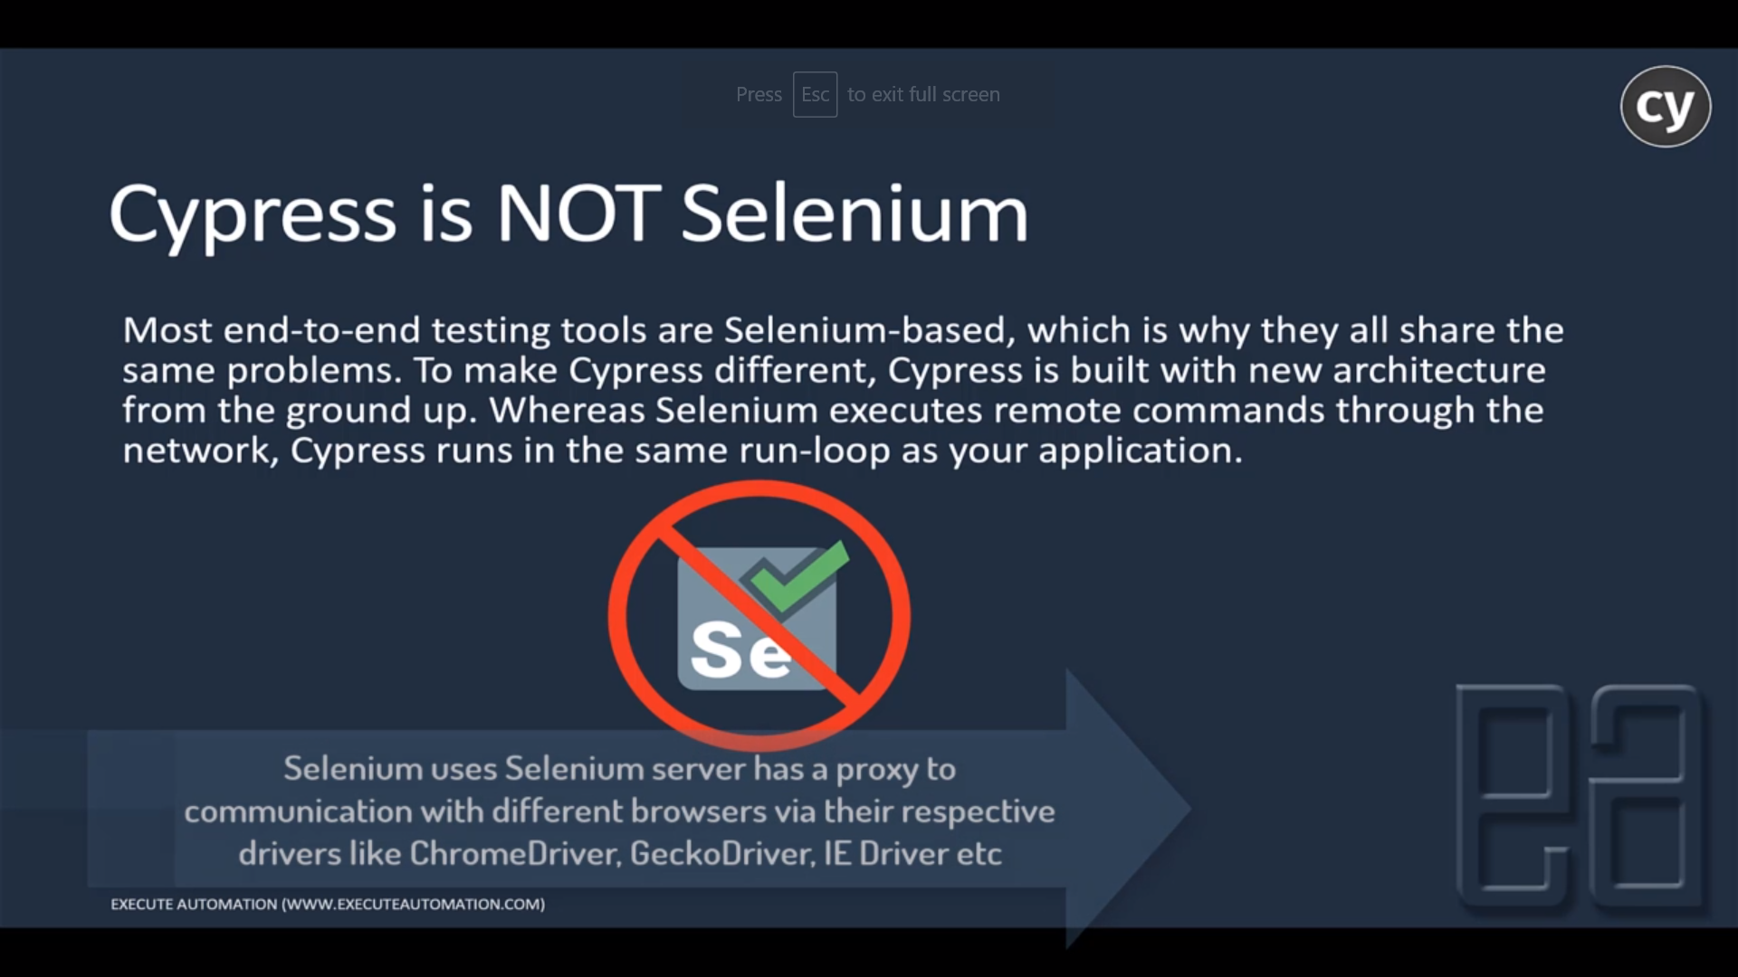

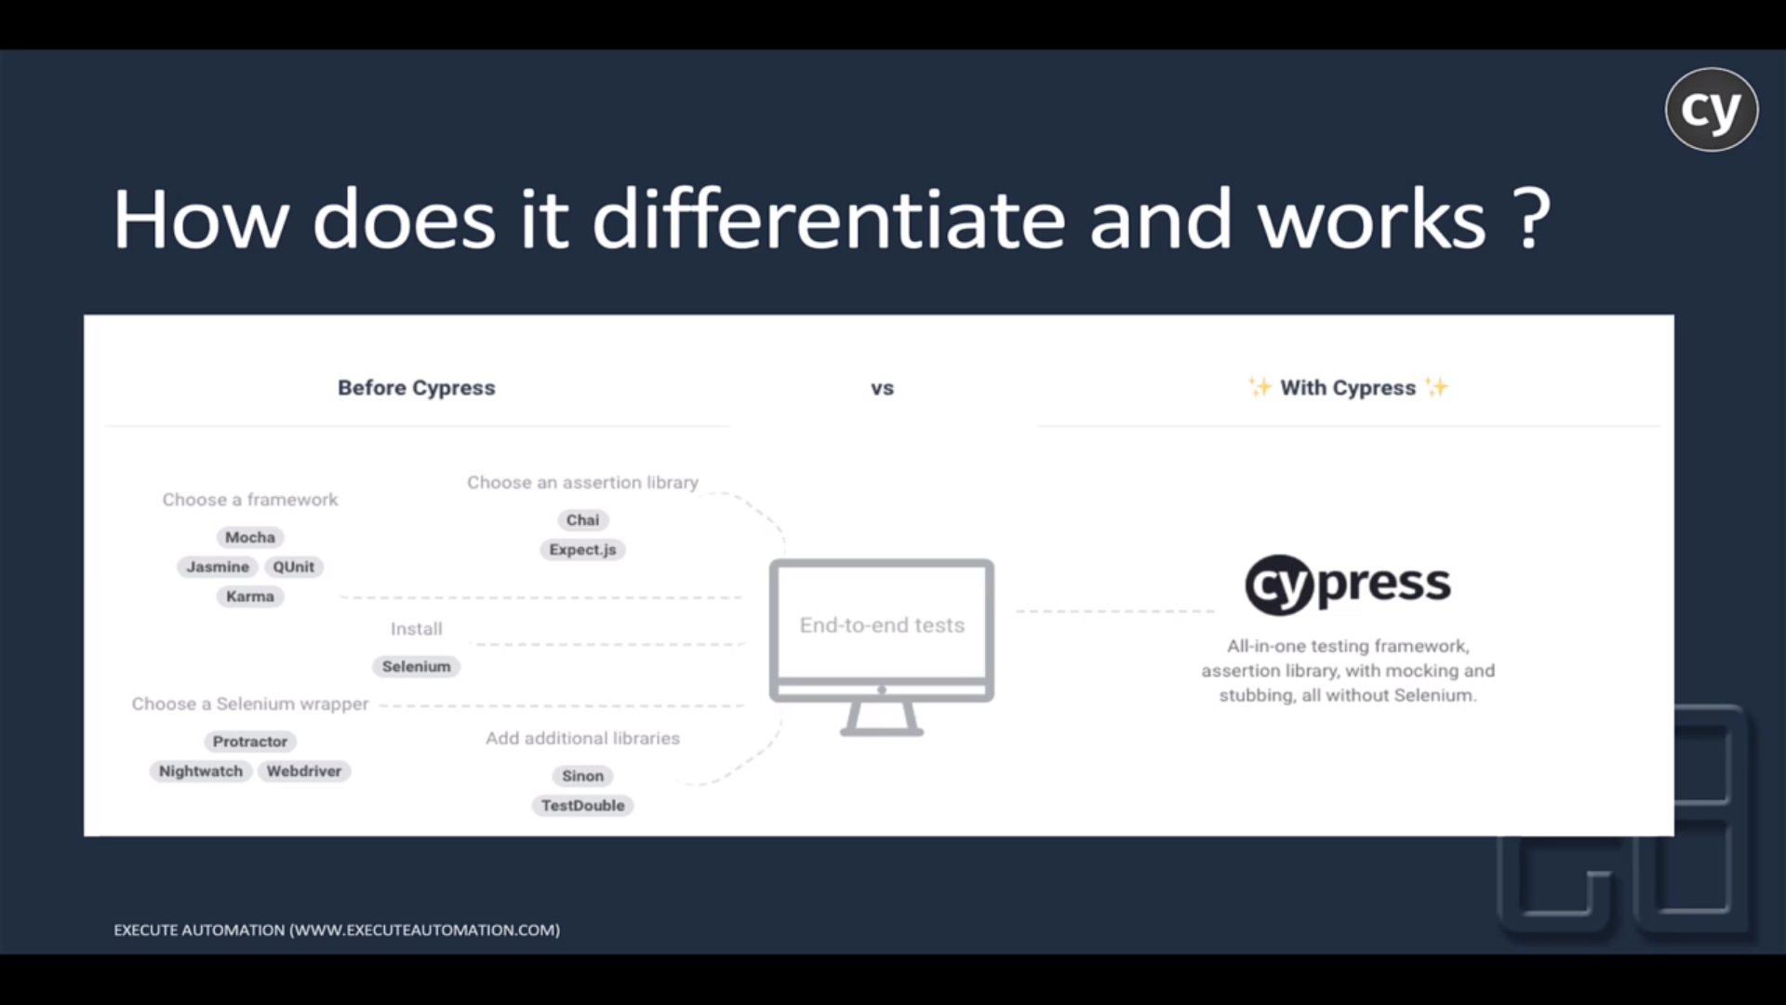

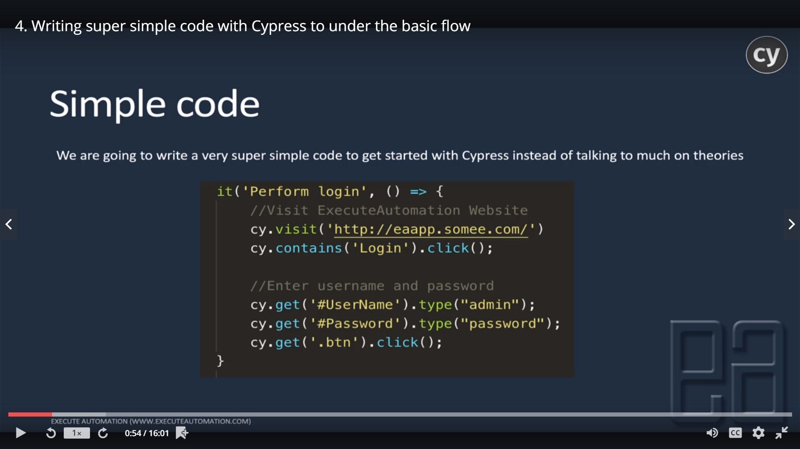

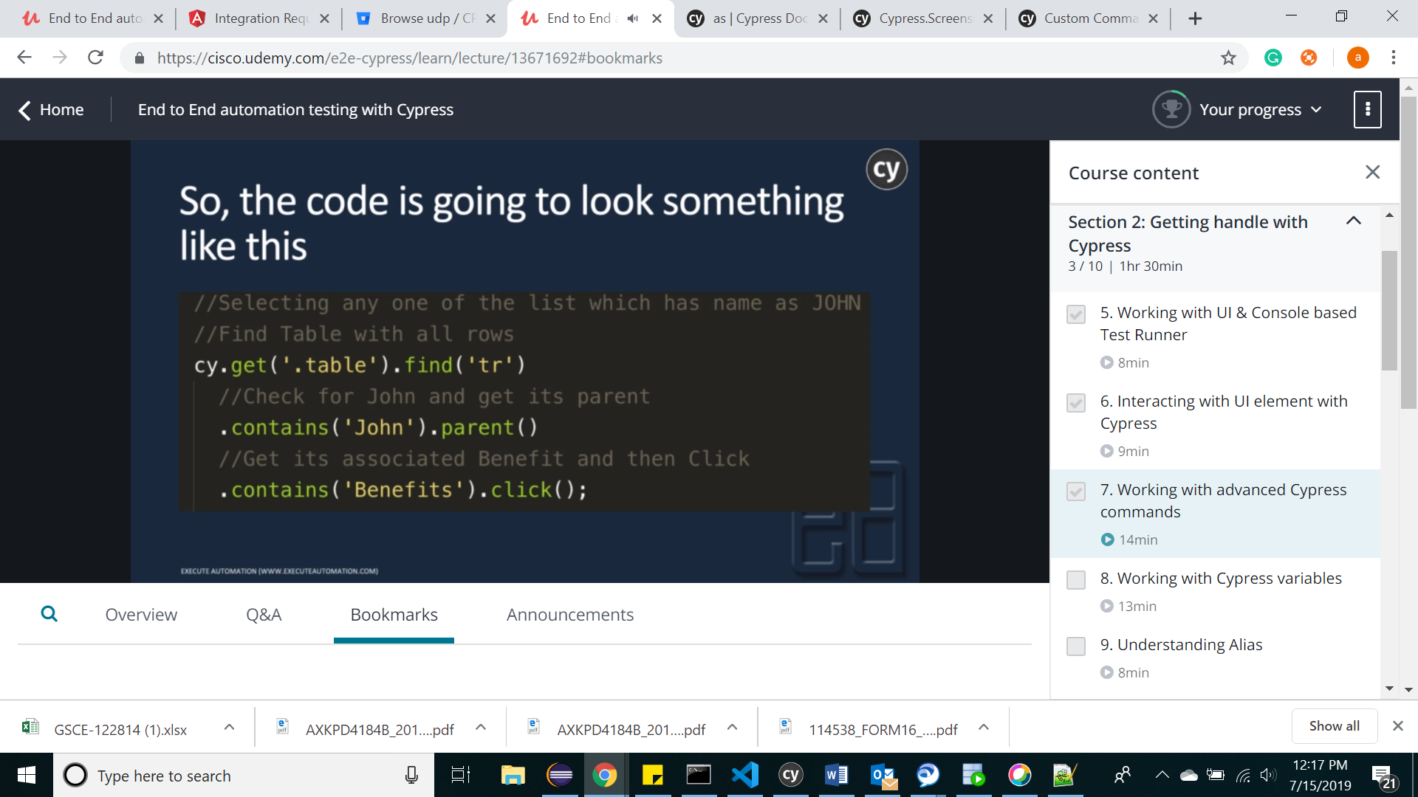

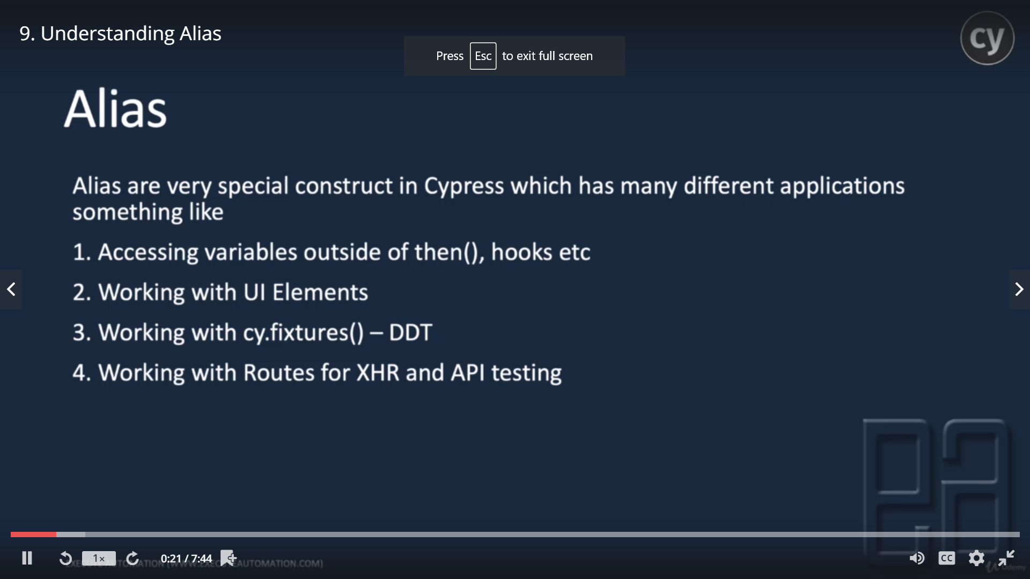

**Cypress Tutorial from Udemy**

**Reference test site:** <https://rahulshettyacademy.com/seleniumPractise/#/>

For all form fields: <https://rahulshettyacademy.com/AutomationPractice/>

Qaclickacademy.com/practice.php

**Chropath plug in:** to easily find the css selectors on the html page

**Installations:**

* Download nodejs(runtime env for JS) from <https://nodejs.org/en/download/>
* Set NODE_HOME env variable
* Download visual studio IDE from <https://code.visualstudio.com/download>
* Create a project and create Package.json file under project
* Mkdir CypressAutomation
* Npm -I init 🡪(create a default package.json)
* On VS->file->open folder->open project folder
* From terminal->
* Install cypress
  + Npm install cypress –save-dev
  + U can see all packages/modules/.exe get installed under node_modules
  + All .exe files will be stored under node_modules/.bin directory

**Package.json:**

So it is a file that exists at the root of your project. This file will help you to store all the metadata relevant to your project and it will help you to manage your project dependencies.

* All project dependencies, plugings, software versions will be configured here.

-Cypress supports below browsers:

-Chrome

-Firefox

-Microsft edge

-Electron(light weight browser,vanilla flavour of chrome without plugins )

-Cypress doesnot support IE

-Cypress by default run in electron browser(Ex: from CLI)

-Cypress is recommending us Mocha for testing framework and it comes with cypress download.

**- Cypress Bundled tools:**

- **Mocha:** Cypress has adopted Mocha's bdd syntax, which fits perfectly with both integration and unit testing. All of the tests you'll be writing sit on the fundamental harness Mocha provides, namely:

* [describe()](http://mochajs.org/#bdd) – It is like a test suite under which we can write many test scenarions/cases using it() function
* [context()](http://mochajs.org/#bdd)
* [it()](http://mochajs.org/#bdd) - it represents a test case. Can have multiple it() in one describe.
* [before()](http://mochajs.org/#hooks)
* [beforeEach()](http://mochajs.org/#hooks)
* [afterEach()](http://mochajs.org/#hooks)
* [after()](http://mochajs.org/#hooks)
* [.only()](http://mochajs.org/#exclusive-tests)
* [.skip()](http://mochajs.org/#exclusive-tests)

Additionally, Mocha gives us excellent [async support](http://mochajs.org/#asynchronous-code). Cypress has extended Mocha, sanding off the rough edges, weird edge cases, bugs, and error messages.

- Chai

-Chai-jQuery

- Sinon.JS

- Sinon-chai

**-Cypress runs in 2 modes.**

1.Headless: Browser will not open, it will be handled internally and only test results will be shown

2.Headmode: Browser will open.

-If you run through command line, cypress always runs in headless by default.

Cypress project framework: cypress open for the first time will create a default below project structure

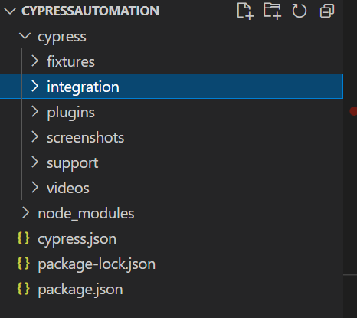

**Fixtures:** Cypress suggests us to put all the test data in fixtures folders. Could be static data in the form of Excel, XML, json etc.

**Integration:** we write all our test cases/spec files under this folder

**Plugins:** u can write listeners in plugins->index.js to write customized code when some event happens.

**Support:** to write all common code, utility methods/spec files under this folder so that cypress by default scans and auto imports this folder and intelligent enough to invoke these methods simply.

**Videos**: all test case videos will be saved here.

**Cypress.json:** We can override default cypress test runner configurations by adding configs here in this file.

**Ex:**

{

defaultCommandTimeout:4000

execTimeout:60000

fixturesFolder:"cypress/fixtures"

integrationFolder:"cypress/integration"

pageLoadTimeout:60000

requestTimeout:5000

responseTimeout:30000

screenshotOnRunFailure:true

screenshotsFolder:"cypress/screenshots"

supportFile:"cypress/support"

video:true

videosFolder:"cypress/videos"

}

-Cypress supports CS selectors only. Ex: class, id, type etc

Id: #idname, Tagname#idname

Class: .classname, Tagname.classname

Attribute: tagname[attribute=value]. Ex: input[type=’search’]

Tagnames: Traverse from parent to child tags with space. Ex: form input

-Cypress CSS selector is very useful to get the attributes we wanted to work on

Ex; 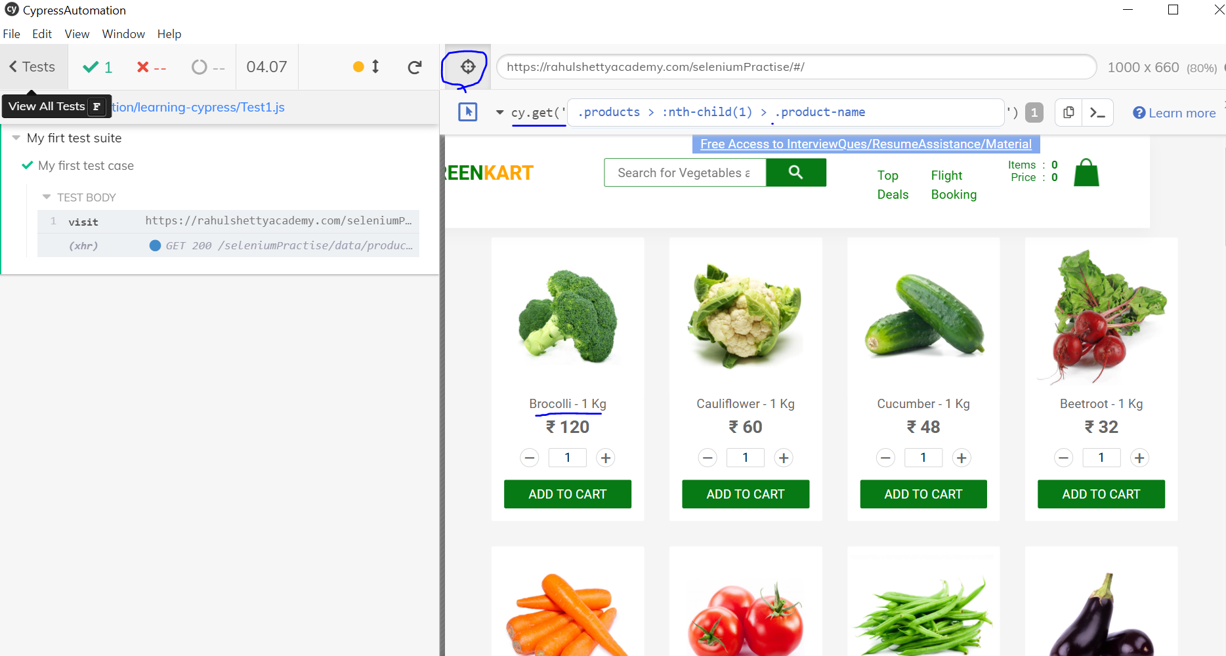

-Intelligent code detection: Add below ine at the top of the file to get auto suggestions

/// <reference types="Cypress" />

-Cypress is Asynchronous in nature, there is no guarantee in sequence of execution but Cypress take care of that to invoke commands in sequence. Since JS is Asynchronous, Cypress is also Async in nature.

-Every step in Async execution return a promise. Promise is nothing but a state of the cmd/step.

**Promise comes with 3 stages:**

* **Resolved:** The command is executed
* **Reject:** There is an error in command
* **Pending:** The command or step is not yet executed

**-**Non Cypress commands cannot resolve promise by themselves. We need to manually resolve using **then()**

**-Aliasing(as()):** Cypress gave as() for aliasing. Using this we can save the locator value in alias/variable.

@alias will give u the value of the locator saved using as().

Ex: cy.get(‘.products’).as(‘productsLocator’)

Now instead of cy.get('.products').find('.product') we can write it as below

cy.get('@ productsLocator’).find('.product')

**-Difference between console.log() and cy.log()**

Console.log() is a JS meth which prints the log in browser developer tools(f12)->console. Where as **cy.log()** prints the log in the test runner.

**Cypress methods:**

**Cy.get():** get is a method to get the locator on the html page.

**Should():** Should is an assertion coming from CHAI library.

**Cy.wait():** Halts the test case to wait for given millisecs

**Find():** from CHAI lib. Will find the given CSS selector under another selector. Ex: cy.get('.products').find('.product')

**Eq():**

**Contains():** is a cypress func to find the given string exists and then do some action.

Ex: cy.contains('Top').click()

**Click():**

**.type():** to type something on the field

**.then():** makes Cypress to wait till the previous step is completed and then call next step.But Cypress internally implemented and wrapped this meth for every step execution and cypress takes care of that.

**.text():** Cypress also supports jquery meths and text is a Jquery method. There is no inbuilt meth in Cypress to get the text out of element.

**.check()/.uncheck()**: Functions to test checkboxes

**.select()**: to test select boxes

**Cy.on(‘window:alert’,param):** Cypress gives on() to capture events on page like alerts etc.

* All assertion functions comes from Mocha. As cypress built on top of Mocha we can make use of all mocha assertions.
* Cypress supports all jquery functions. So we can use them to achieve some functionalities
* Cypress doesn’t allow you to switch to the child browser on clicking on some link unlike selenium and protractor

**.invoke()** is a js function. Here we asked to remove target attribute so that in Cypress test window, new child window will not open instead it redirects to the new page.

Ex:cy.get(‘#opentab’).invoke(‘removeAttr’.’target’).click()

**Cy.go(‘back’):** go() is used to go back or forward to the previous or next pages in cypress.

Ex:cy.go(‘forward’)

**Cy.url():** use to get the url of current page

**.next():** is a cypress func to get the next sibling of the current tag/dom

**.click({force:true}):** to force click on the invisible element

* Mousehovers are not supported in Cypress. Use .invoke(‘show’) js method to test it.

**.prop():** is a JS method to grab the value for the html attribute.To use any JS meth with Cypress we have to resolve the promise and then call JS meth on top of the element.

Ex: prop(‘href’)

Cy.pause()/cy.debug(): to pause the execution

-iframe is a html doc embedded in another html doc.

To work on iframes we need to install a iframe plug in as below under the project.

>npm install -D cypress-iframe

**Assertions**

Should(‘have.value’)

Should(‘include’,’<string>’)

expect(price).to.equal('25')

**Cypress commands:**

**>cypress open 🡪to open cypress test runner**

**>cypress run 🡪Runs all spec files under Integration folder**

**>cypress run - - spec “path of spec file” -> to run a single spec file**

**>cypress run - -headed 🡪 to run in head mode**

**>cypress run –browser chrome 🡪to run in particular browser**

**Cypress concepts:**

**Cypress Hooks: ref:** [**https://docs.cypress.io/guides/core-concepts/writing-and-organizing-tests#Hooks**](https://docs.cypress.io/guides/core-concepts/writing-and-organizing-tests#Hooks)

describe('Hooks', () => {

before(() => {

// runs once before all tests in the block

})

beforeEach(() => {

// runs before each test in the block

})

afterEach(() => {

// runs after each test in the block

})

after(() => {

// runs once after all tests in the block

})

})

**Fixtures:** If we place our data in fixtures folders as json format, Cypress will get that data and load it in our test cases

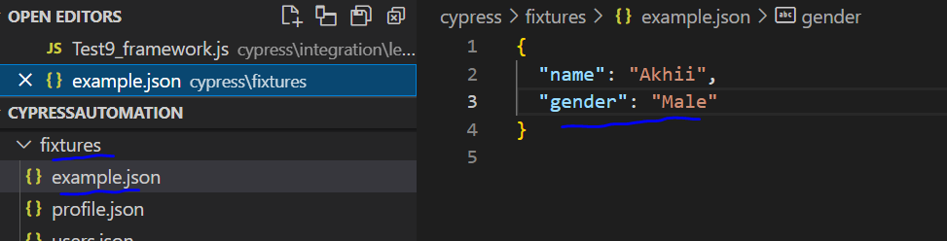

* All fixtures loading is recommended to write in before hook

Ex: describe('Iframe test',function(){

//get data from fixture in before hook

    before(function(){

        cy.fixture('example').then(function(data){

//since we can’t access function(data) outside of the function block, assign it to class variable and use it anywhere in the class as below

            this.cdata=data

        })

    })

    it('Iframe test', function(){

        cy.visit('https://rahulshettyacademy.com/angularpractice')

//now get name from clas variable

        cy.get(':nth-child(1) > .form-control').type(this.cdata.name)

        cy.get('select').select(this.cdata.gender)

    })

})

**Support/commands.js:** is present to accept all the custom methods. We will declare a command for the method and by calling that command we can access this custom method in our spec file.

Once we declare a command in commands.js, we can call that command using cy.<commandname>

Ex:in commands.js:

Cypress.Commands.add('selectProduct', (productName) => {

    //click on shop, add supplied product to the cart

    cy.get(':nth-child(2) > .nav-link').click()

    cy.get('h4.card-title').each(($el,index,$list)=>{

        if($el.text().includes(productName)){

            cy.get('button.btn.btn-info').eq(index).click()

        }

    })

 })

**In spec file:**

cy.selectProduct('Nokia Edge')

-We can debug using inspect on cypress runner browser by clicking on timetravels as shown below

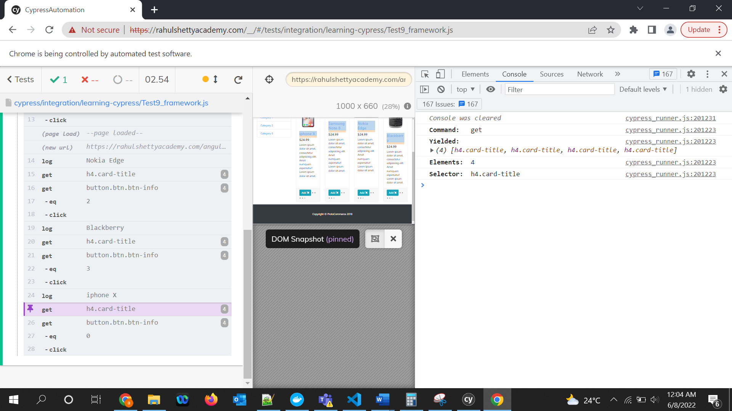

**Page Object model/Design pattern:** Maintaining objects at page level by separating and putting that particular page objects in a separate class is called Page object model. In this way if tomorrow we want to change something on particular page then if we make change in that class the issue would resolve otherwise we have to make changes in multiple files.

Definition: ***A page object*** is a ***class*** that represents a page in the web application. Under this model, the overall web application breaks down into logical pages. Each page of the web application generally corresponds to one class in the page object, but can even map to multiple classes also, depending on the classification of the pages. This Page class will contain all the ***locators*** of the WebElements of that web page and will also contain ***methods*** that can perform operations on those WebElements.

Ref: <https://www.toolsqa.com/cypress/page-object-pattern-in-cypress/>

//Below config override works from this line till the test execution complete(it block completes)

Cypress.config('defaultCommandTimeout',10000)

Setting env variable from command prompt:

>node_modules\.bin\cypress run - -spec cypress/integration/examples/Test8Framework.js

**Cypress Dashboard:**

<https://docs.cypress.io/guides/dashboard/introduction>

Create a project,copy project key and put it in cypress.json

"projectId": "5z3ynh",

Run record key command in the terminal:

npx cypress run --record --key 8e29b17b-a8c4-4e3f-b98f-bc5aecdeab9

Then your tests under integration folder will start run

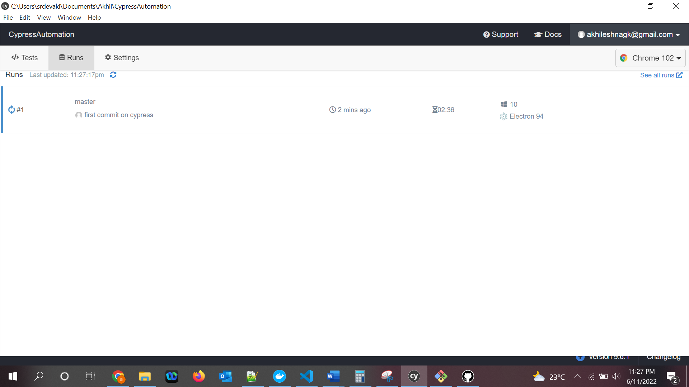

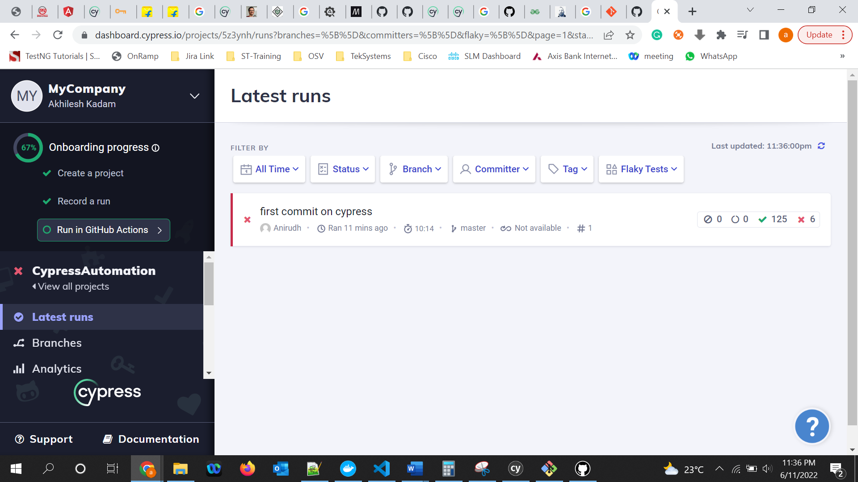

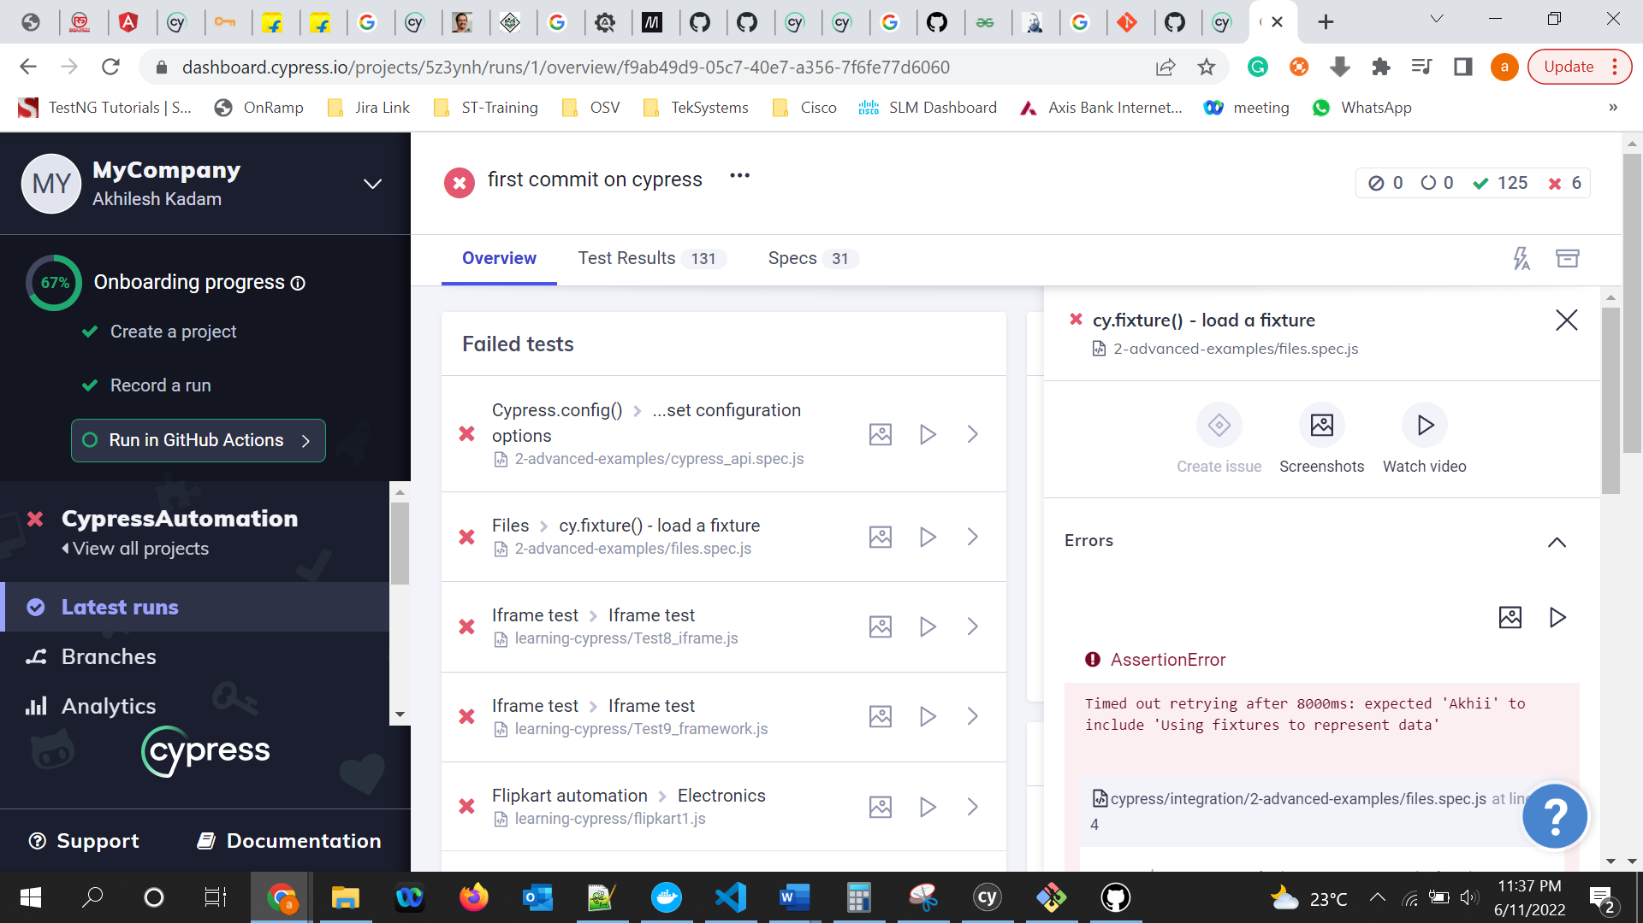

**Reports using Mocha:**

To see the reports on repository only but not on external dashboard like above then we can create HTML dashboard using **Mochawesome plugin.**

npm install --save-dev mochawesome

* Mochawesome depends on mocha framework. Though Cypress internally have and install mocha, Mochawesome expects mocha as a eperate folder. So install mocha.
* Npm install –save-dev mocha
* 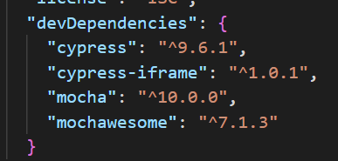
* Add "reporter": "mochawesome", in cypress.json
* Run below command to run tests and save reports:
  + Cypress run –reporter mocahwesome
  + 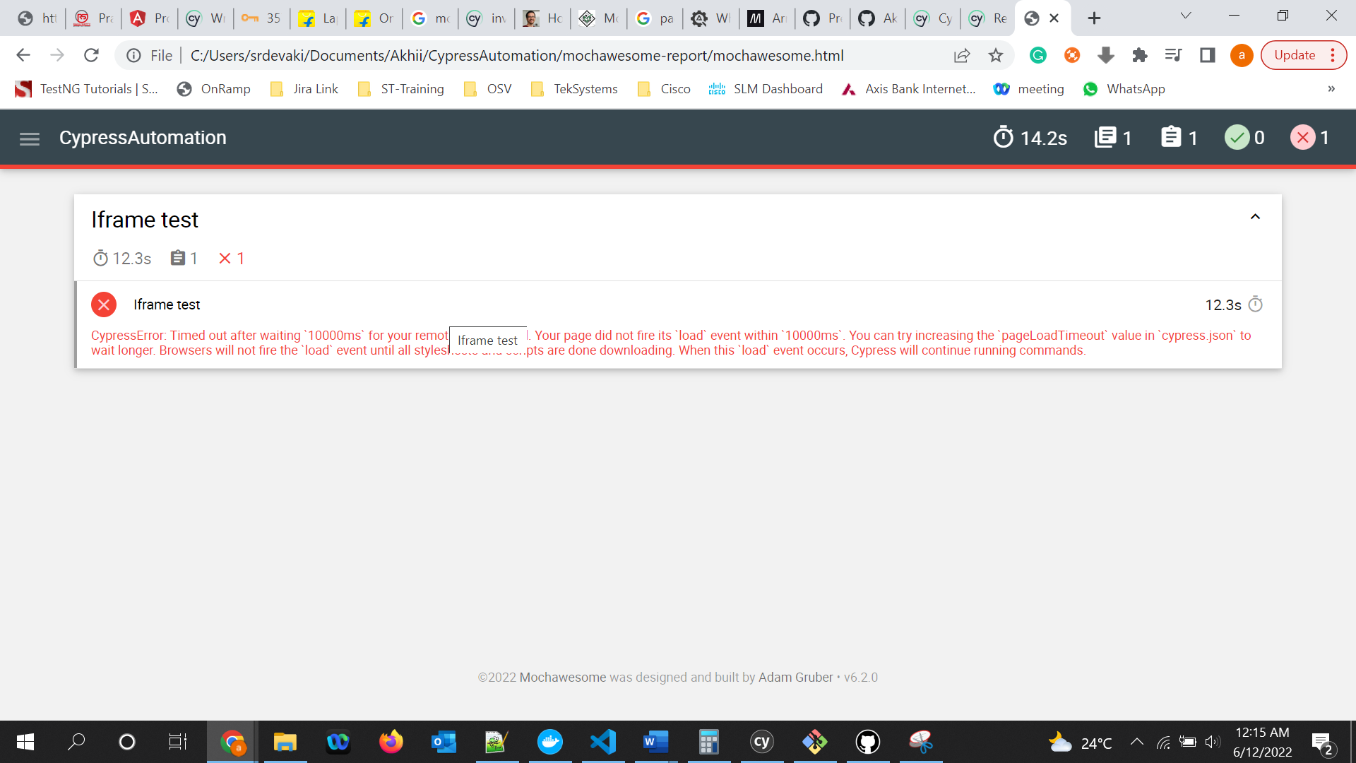

All reports will be saved under mochawesome folder;

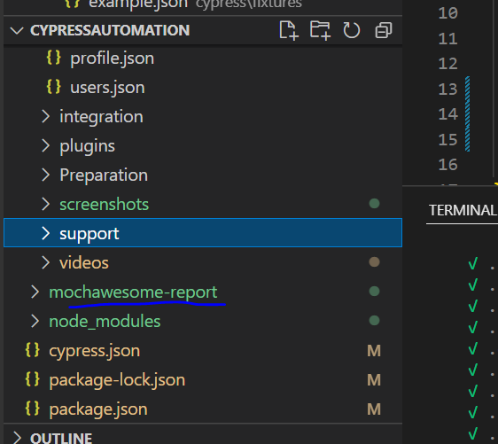

***If you want to change /install diff version of dependency then after initial installation of dependency, change the version in package.json and again just give “npm install”. This will check and download all the versions given in the package.json

**Cypress Command line:**

**Ref:** [**https://docs.cypress.io/guides/guides/command-line#How-to-run-commands**](https://docs.cypress.io/guides/guides/command-line#How-to-run-commands)

**Create custom scripts on package.json:**

Write custom scripts under script tag in package.json and run the script as >npm run <scriptname>.

When you use existing script in new script, don’t forget to end it with “--” as shown below

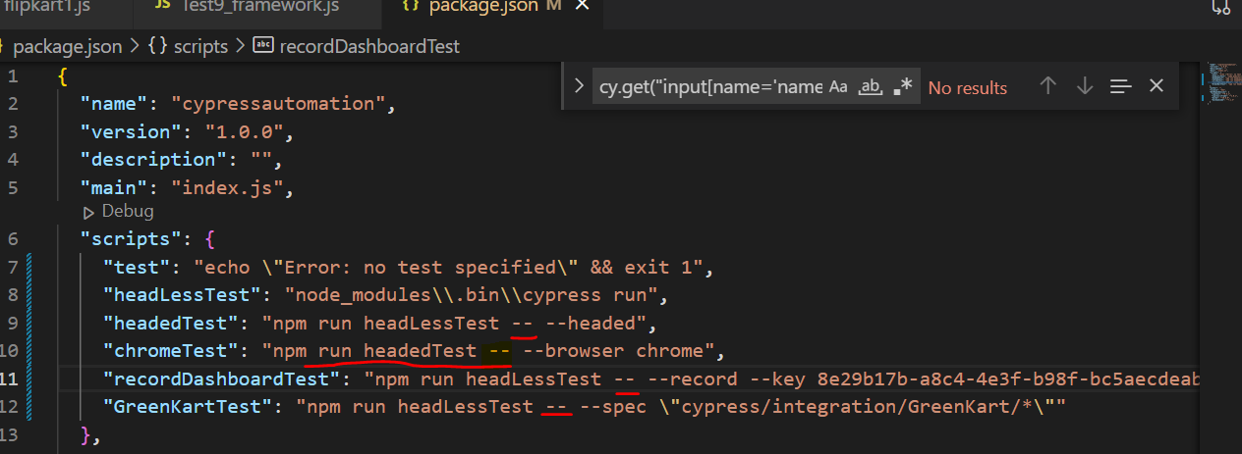

Cypress test Retry: By default retry will be disabled. Have to config that in cypress.json to enable retry.

Ref: <https://docs.cypress.io/guides/guides/test-retries#Global-Configuration>

Add below to cypress.json:

"retries": {

        "runMode": 2

    }

**Cypress with Jenkins:**

Setup:

* Download Jenkins .war file from <https://www.jenkins.io/download/>
* Open cmd and navigate to .war file directory and start the Jenkins with below cmd
  + Java -jar Jenkins.war -httpPort=8080

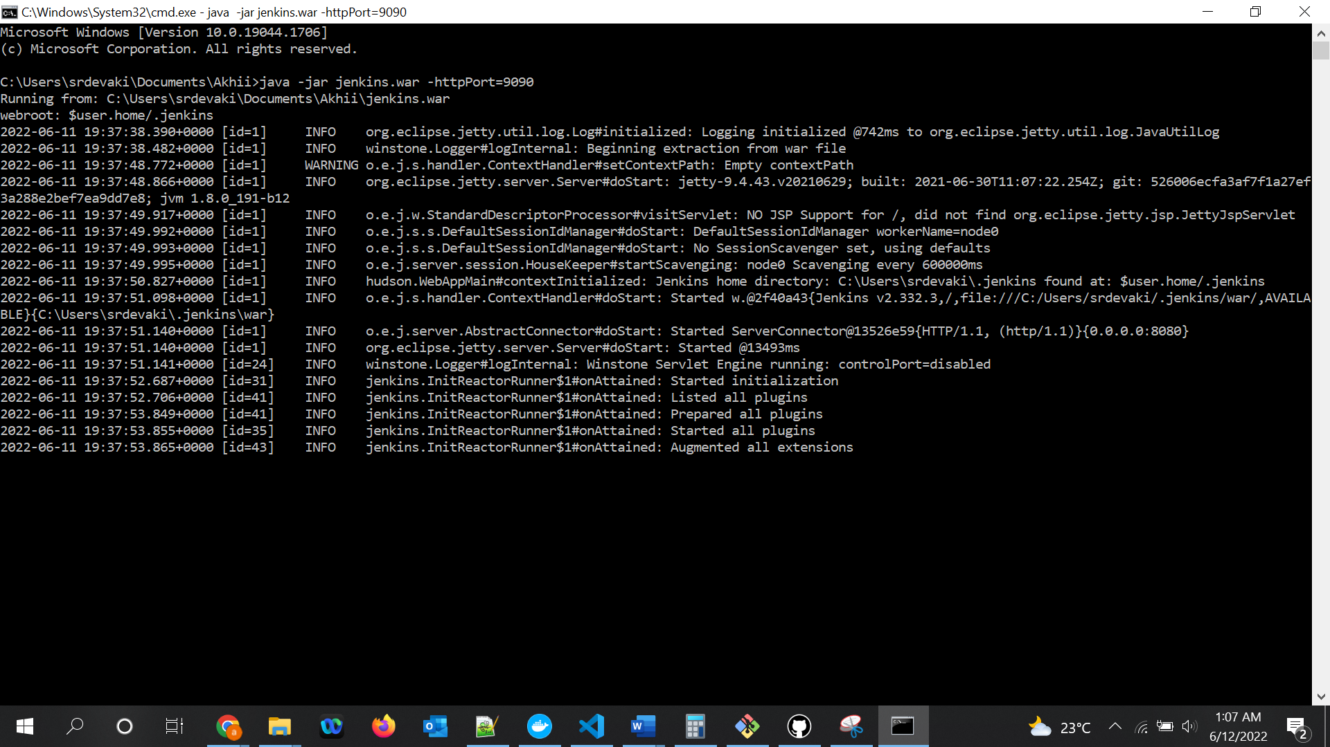

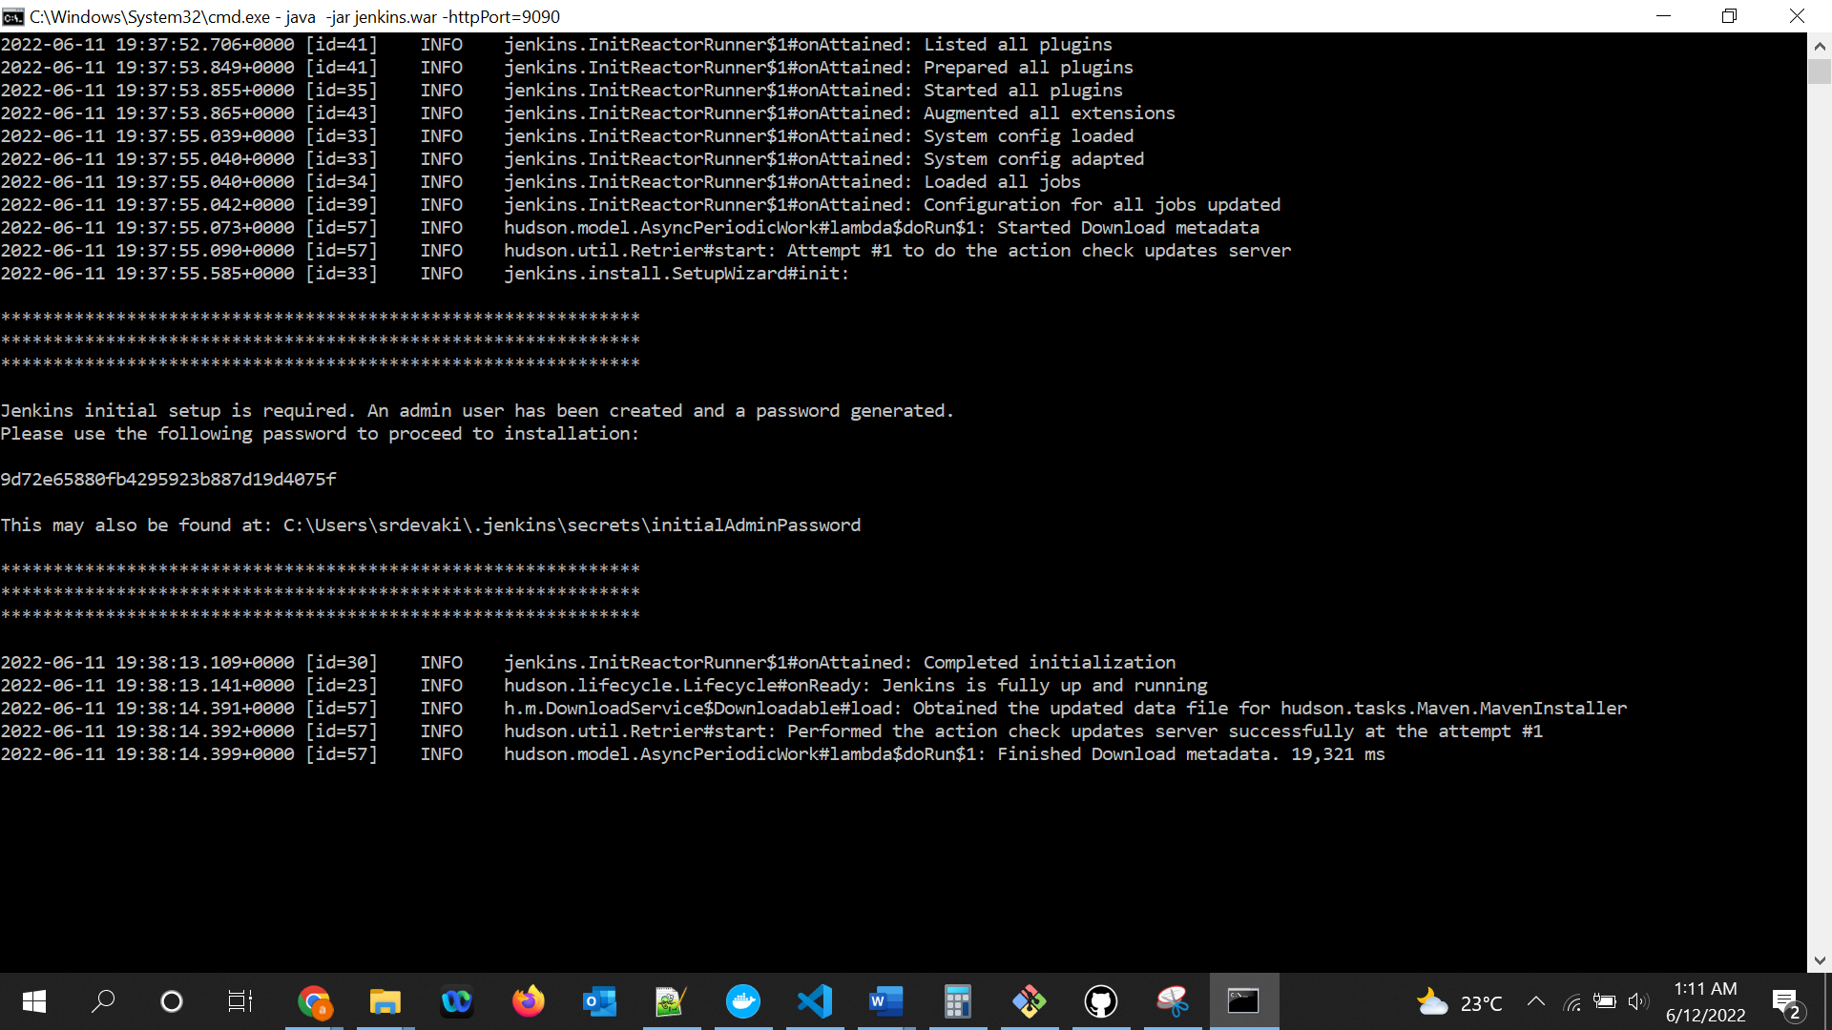

Jenkins initial setup is required. An admin user has been created and a password generated.

Please use the following password to proceed to installation:

9d72e65880fb4295923b887d19d4075f

This may also be found at: C:\Users\srdevaki\.jenkins\secrets\initialAdminPassword

*************************************************************

*************************************************************

*************************************************************

2022-06-11 19:38:13.109+0000 [id=30] INFO jenkins.InitReactorRunner$1#onAttained: Completed initialization

2022-06-11 19:38:13.141+0000 [id=23] INFO hudson.lifecycle.Lifecycle#onReady: Jenkins is fully up and running

2022-06-11 19:38:14.391+0000 [id=57] INFO h.m.DownloadService$Downloadable#load: Obtained the updated data file for hudson.tasks.Maven.MavenInstaller

2022-06-11 19:38:14.392+0000 [id=57] INFO hudson.util.Retrier#start: Performed the action check updates server successfully at the attempt #1

2022-06-11 19:38:14.399+0000 [id=57] INFO hudson.model.AsyncPeriodicWork#lambda$doRun$1: Finished Download metadata. 19,321 ms

Hit below url: localhost:8080

New Item🡪Project/Job name: CypressAutomation🡪 select freestyle project🡪 click ok

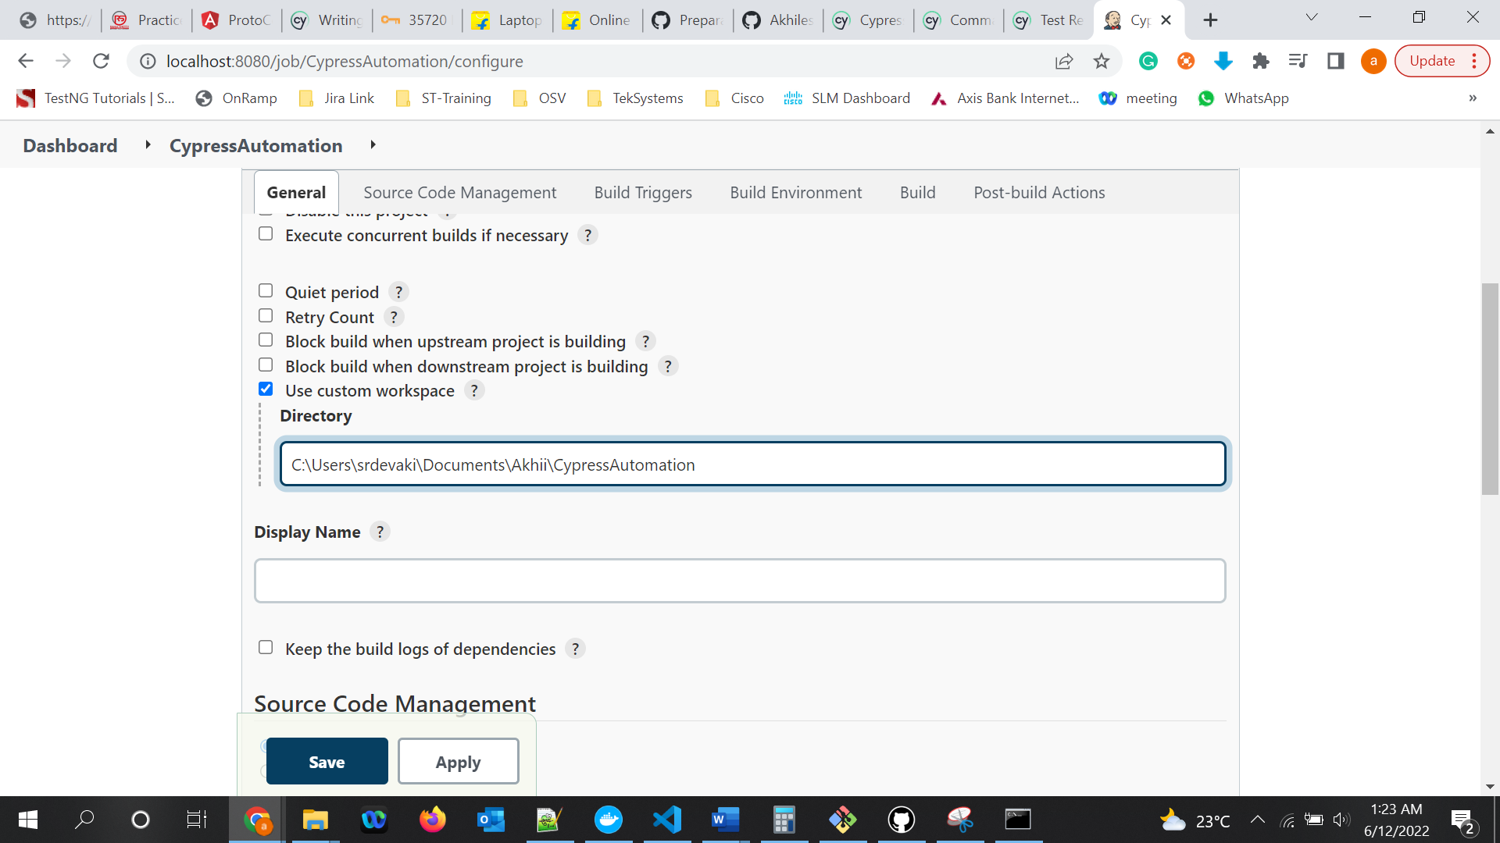

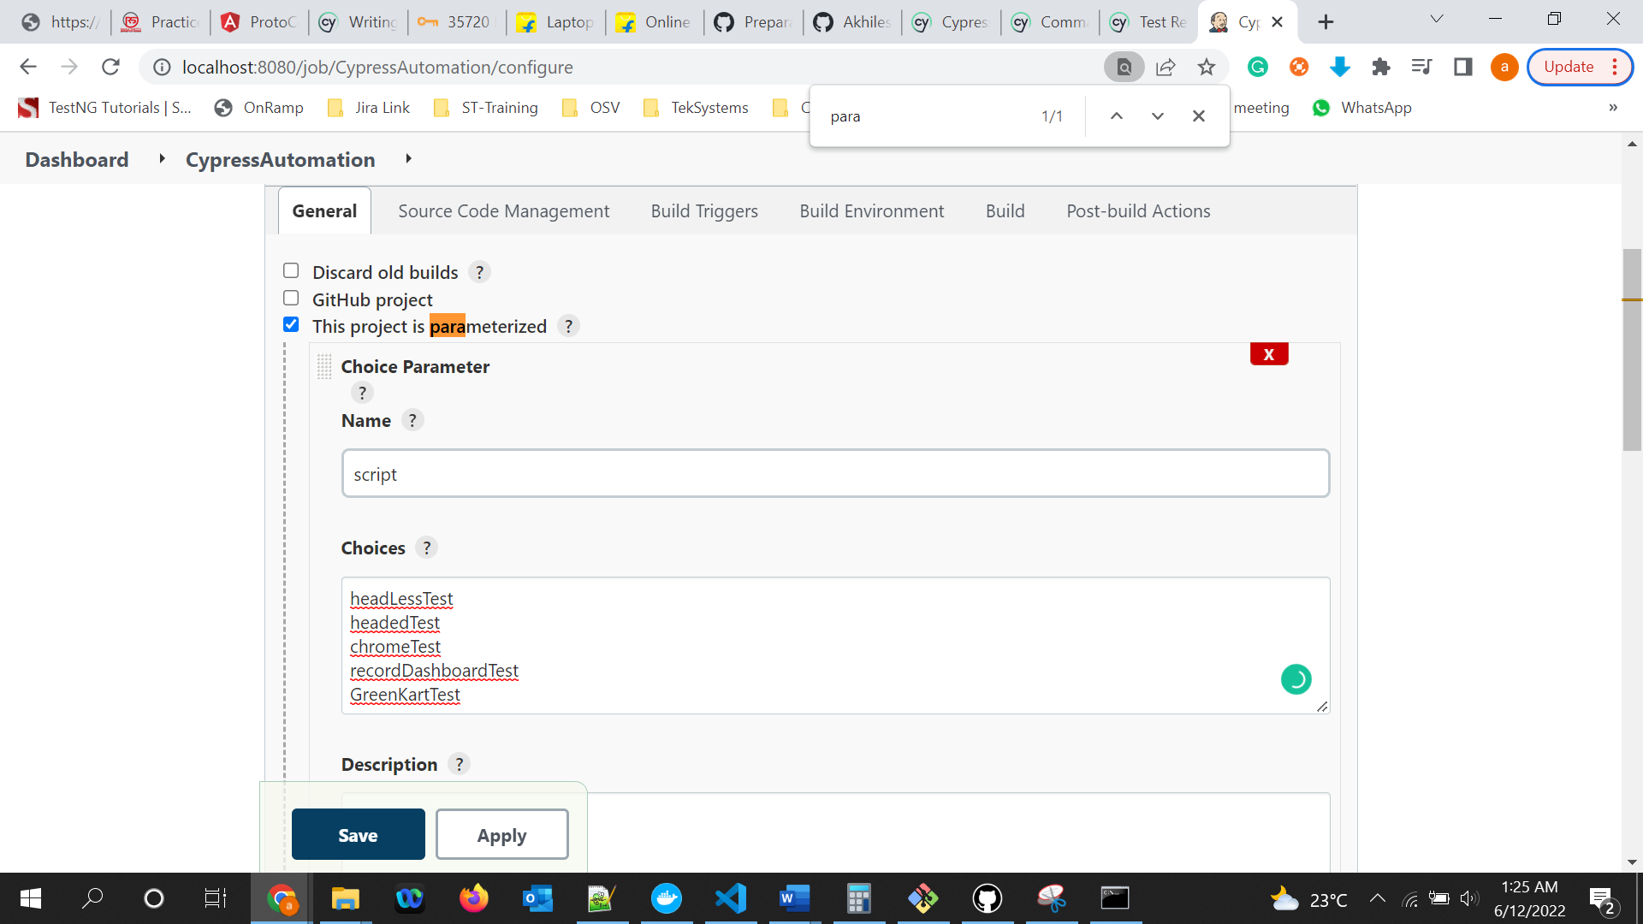

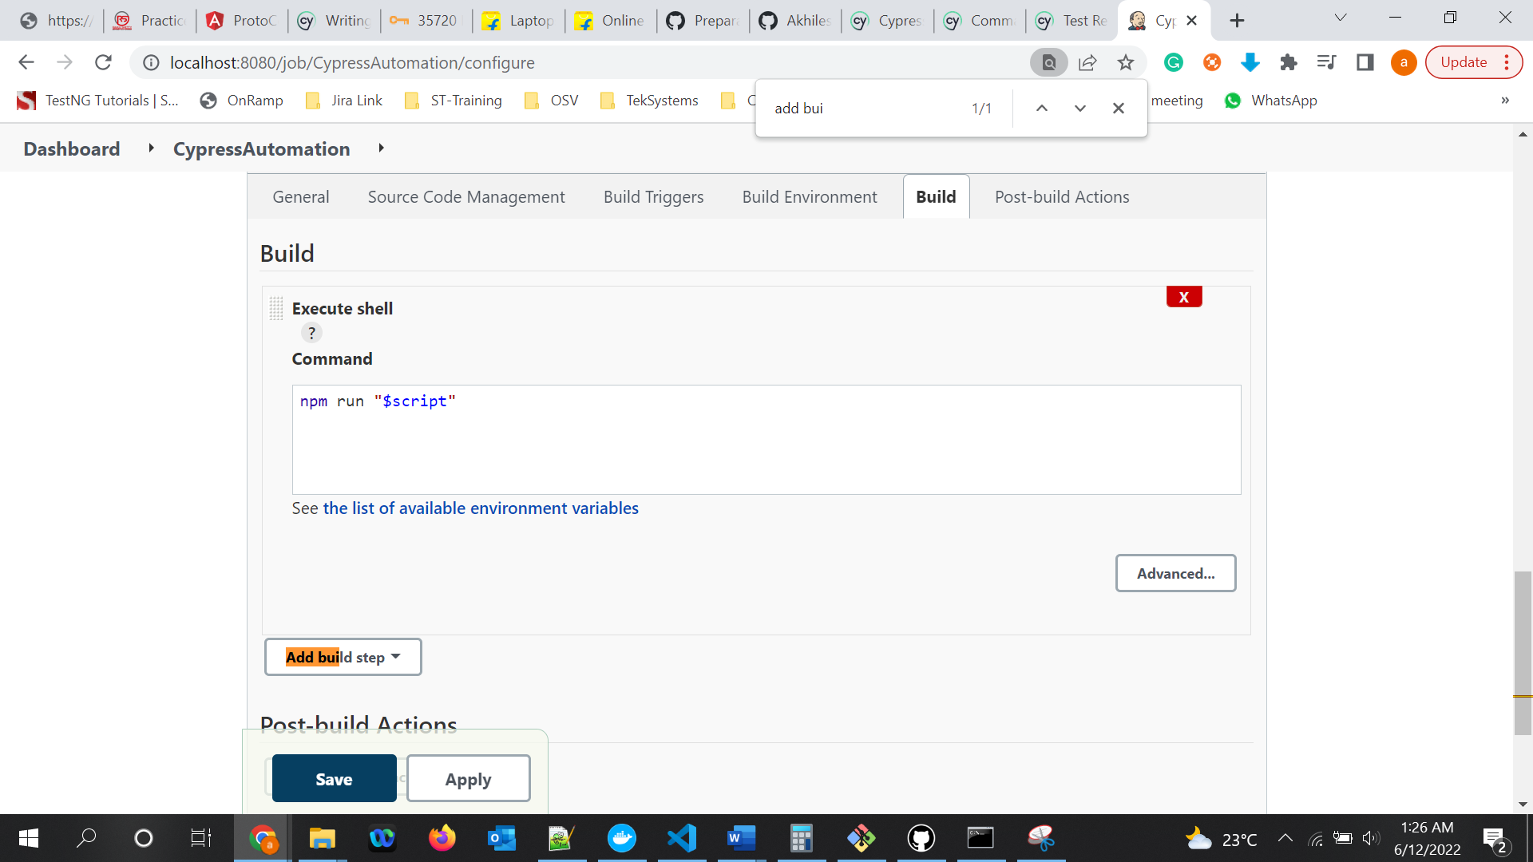

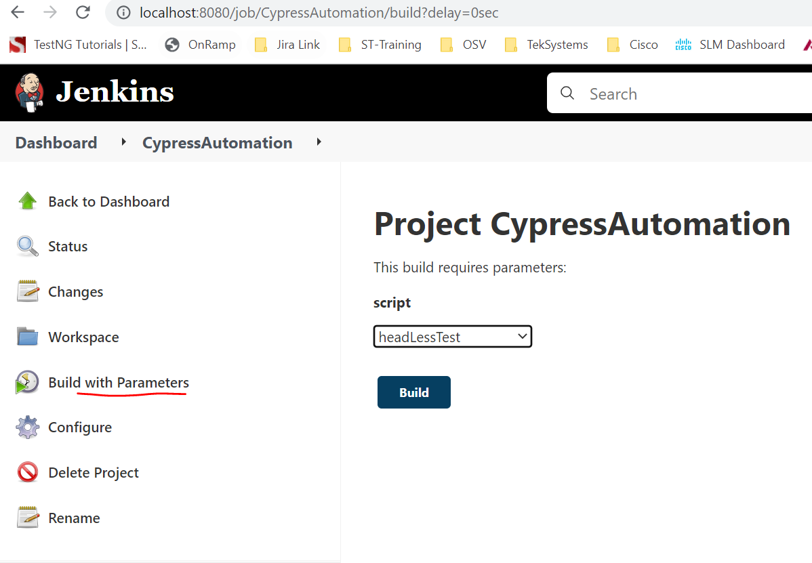

**BDD(Behavioral driven development):**

**Reference:** [https://cucumber.io/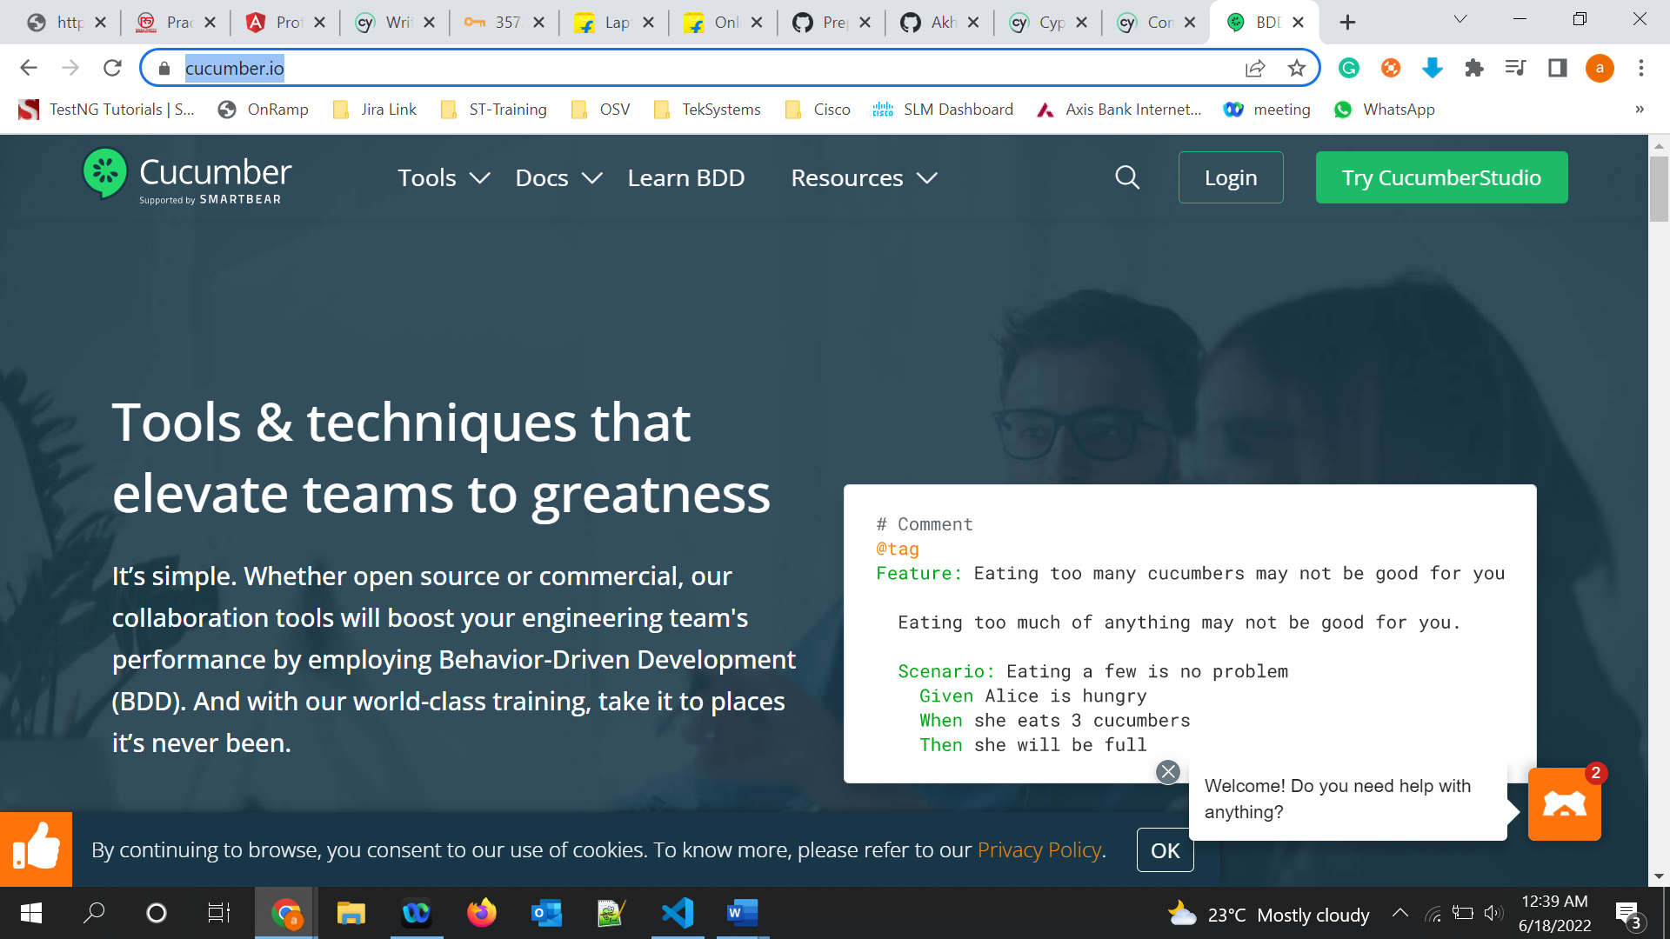](https://cucumber.io/)

The above scenario is called Gherkin syntax.

**Cucumber installation in cypress:**

**Ref:** [**https://www.npmjs.com/package/cypress-cucumber-preprocessor**](https://www.npmjs.com/package/cypress-cucumber-preprocessor)

Terminal>npm install --save-dev cypress-cucumber-preprocessor

**Cypress Configuration**

Add it to your plugins:

cypress/plugins/index.js

const cucumber = require('cypress-cucumber-preprocessor').default

// This function is called when a project is opened or re-opened

module.exports = (on, config) => {

on('file:preprocessor', cucumber())

}

By Adding above, Cypress will be able to load and understand cucumber related syntax. Before execution all loading will happen here in this file and we can work with our tests.

* Since cucumber works on Gherkin syntax and this will be written in .feature files, to recognize .feature files by cypress give below:
* Add support for feature files to your Cypress configuration
* cypress.json
* {
* "testFiles": "**/*.feature"
* }

-To link gherkin syntax/feature file with the cypress code(step definition file), configure below

### Configuration

Please make use of **[cosmiconfig](https://github.com/davidtheclark/cosmiconfig)** to create a configuration for the plugin, for example, by adding this section to your package.json:

"cypress-cucumber-preprocessor": {

"nonGlobalStepDefinitions": true

}

Install cucumber BDD extension:

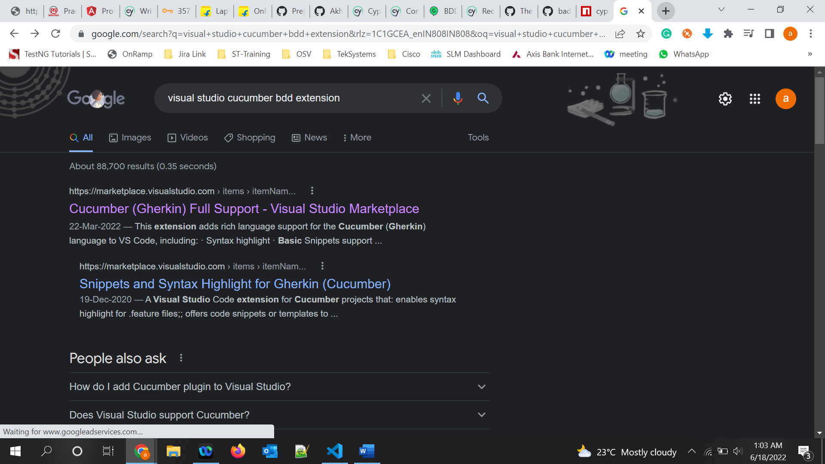

Write feature files as below reference:

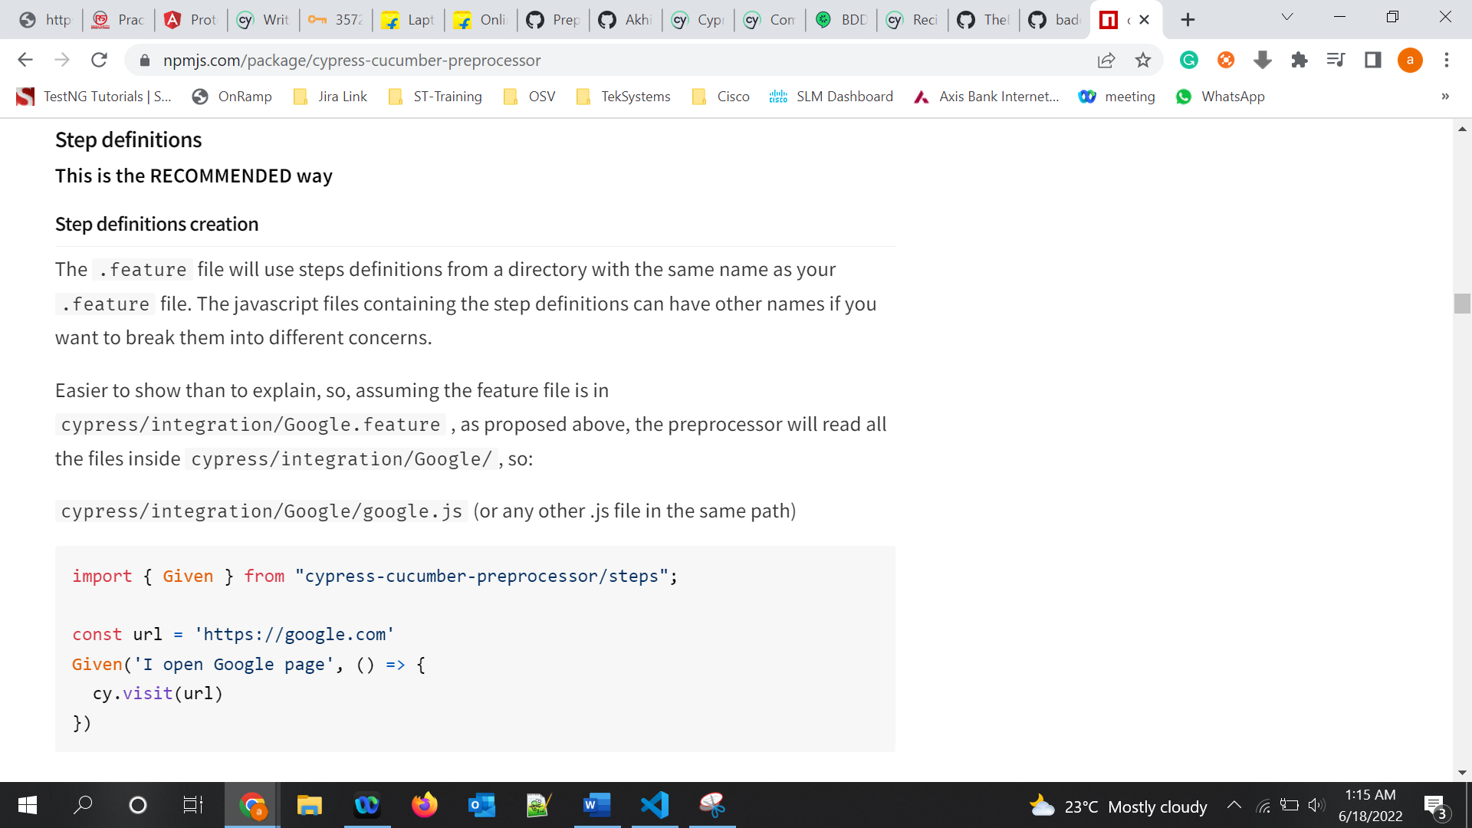

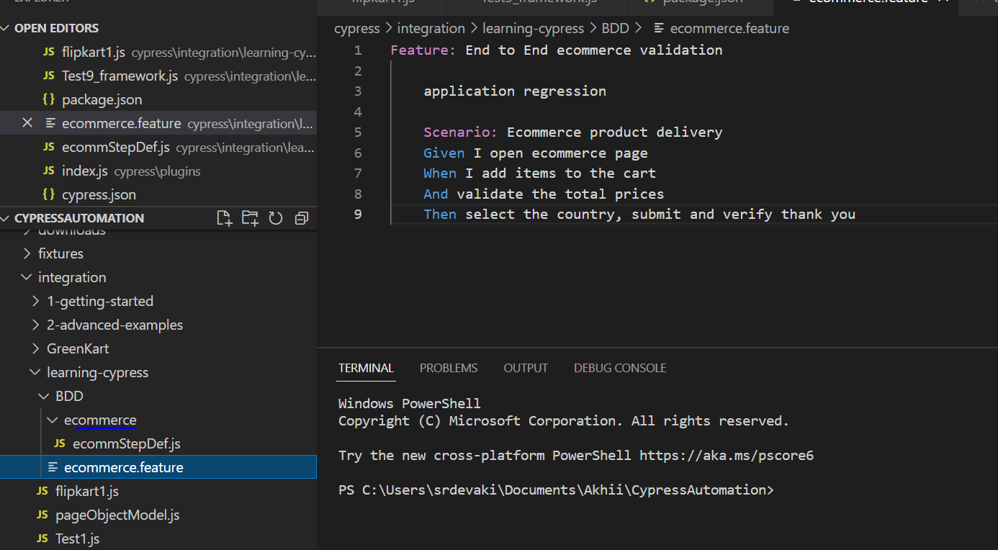

Data driven testing using cucumber data table feature :

Scenario: Filling the form to shop

    Given I open the ecommerce page

    When I fill the form details

    |name |gender |

    |nag |Male |

    Then validate the form details

    And select the shop page

In sstepDef.js

when('When I fill the form details',function(dataTable){

    name = dataTable.rawTable[1][0]

    homePage.getNameField().type(dataTable.rawTable[1][0])

    homePage.getGenderSelect().select(dataTable.rawTable[1][1])

})

To run all the feature files using terminal:

Cypress run –spec <path to BDD folder>\*.feature –headed –browser chrome

To run single spec:

Cypress run –spec <path to BDD folder>\ecommerce.feature –headed –browser chrome

To run with Tags: (useful to run only particular tags but not all tests)

Npx cypress-tags run -e TAGS=”@Smoke” –headed –browser chrome

**Cucumber HTML report:**

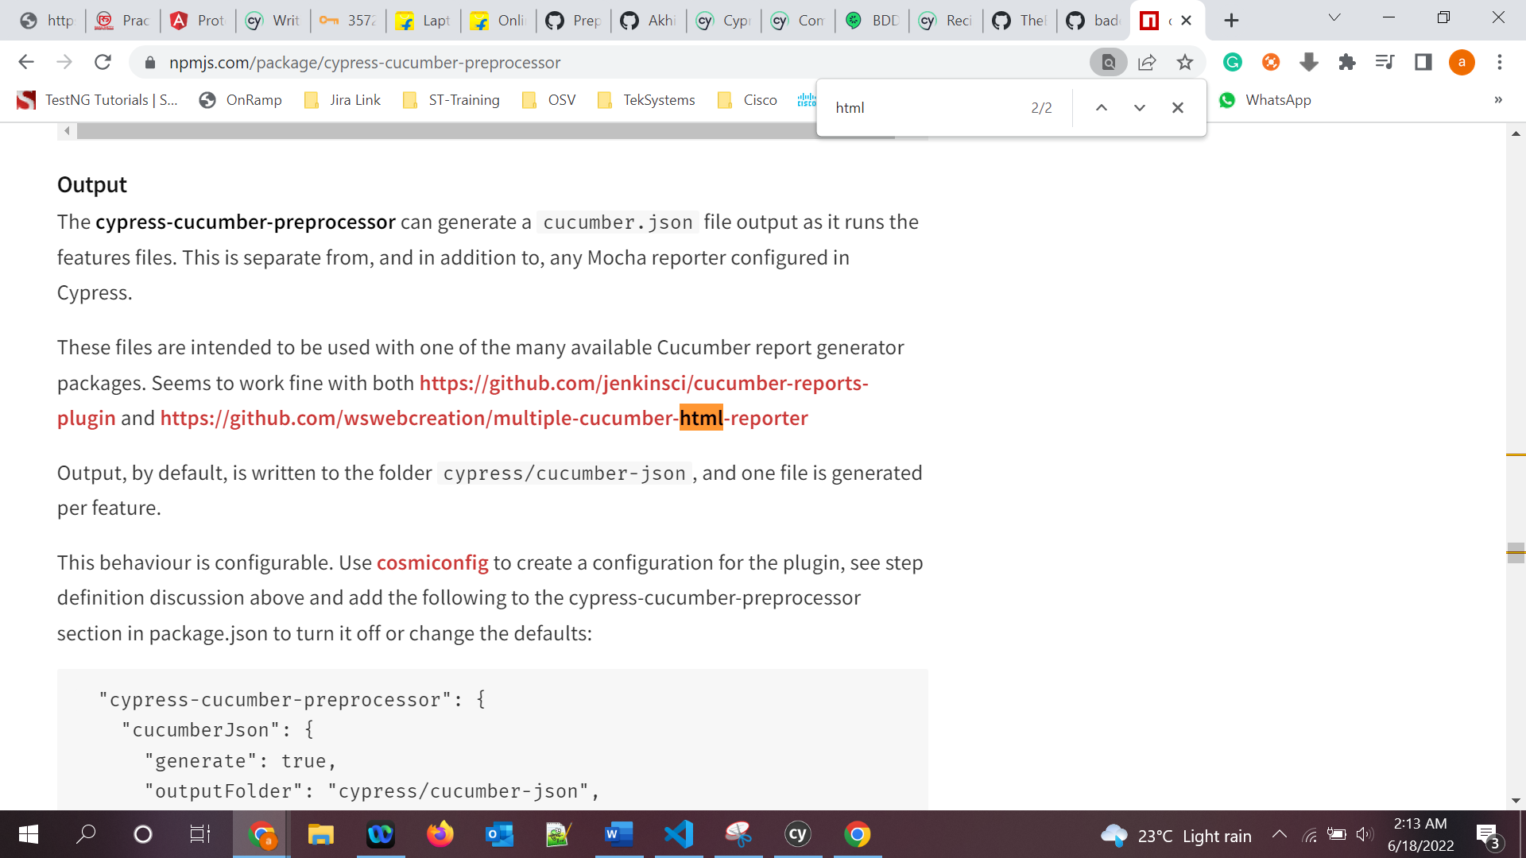

This behaviour is configurable. Use **[cosmiconfig](https://github.com/davidtheclark/cosmiconfig)** to create a configuration for the plugin, see step definition discussion above and add the following to the cypress-cucumber-preprocessor section in package.json to turn it off or change the defaults:

"cypress-cucumber-preprocessor": {

"cucumberJson": {

"generate": true,

"outputFolder": "cypress/cucumber-json",

"filePrefix": "",

"fileSuffix": ".cucumber"

}

}

Install a plug in to view the report in HTML:

npm install multiple-cucumber-html-reporter --save-dev

-and also add below .js file:

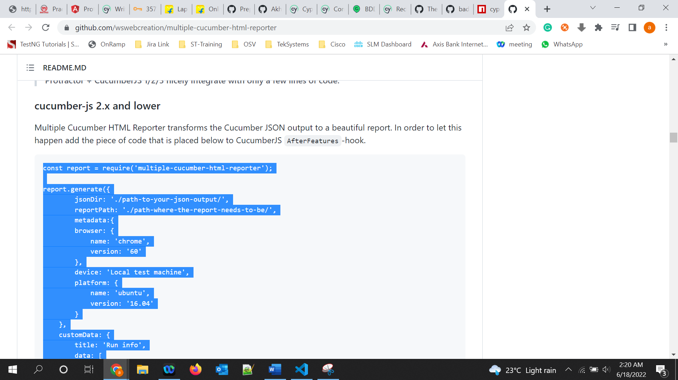

Terminal> node cucumber-html-report.js

**Cypress intercept to manage HTTP requests**

* Using cypress we can even modify requests/responses of API calls.
* 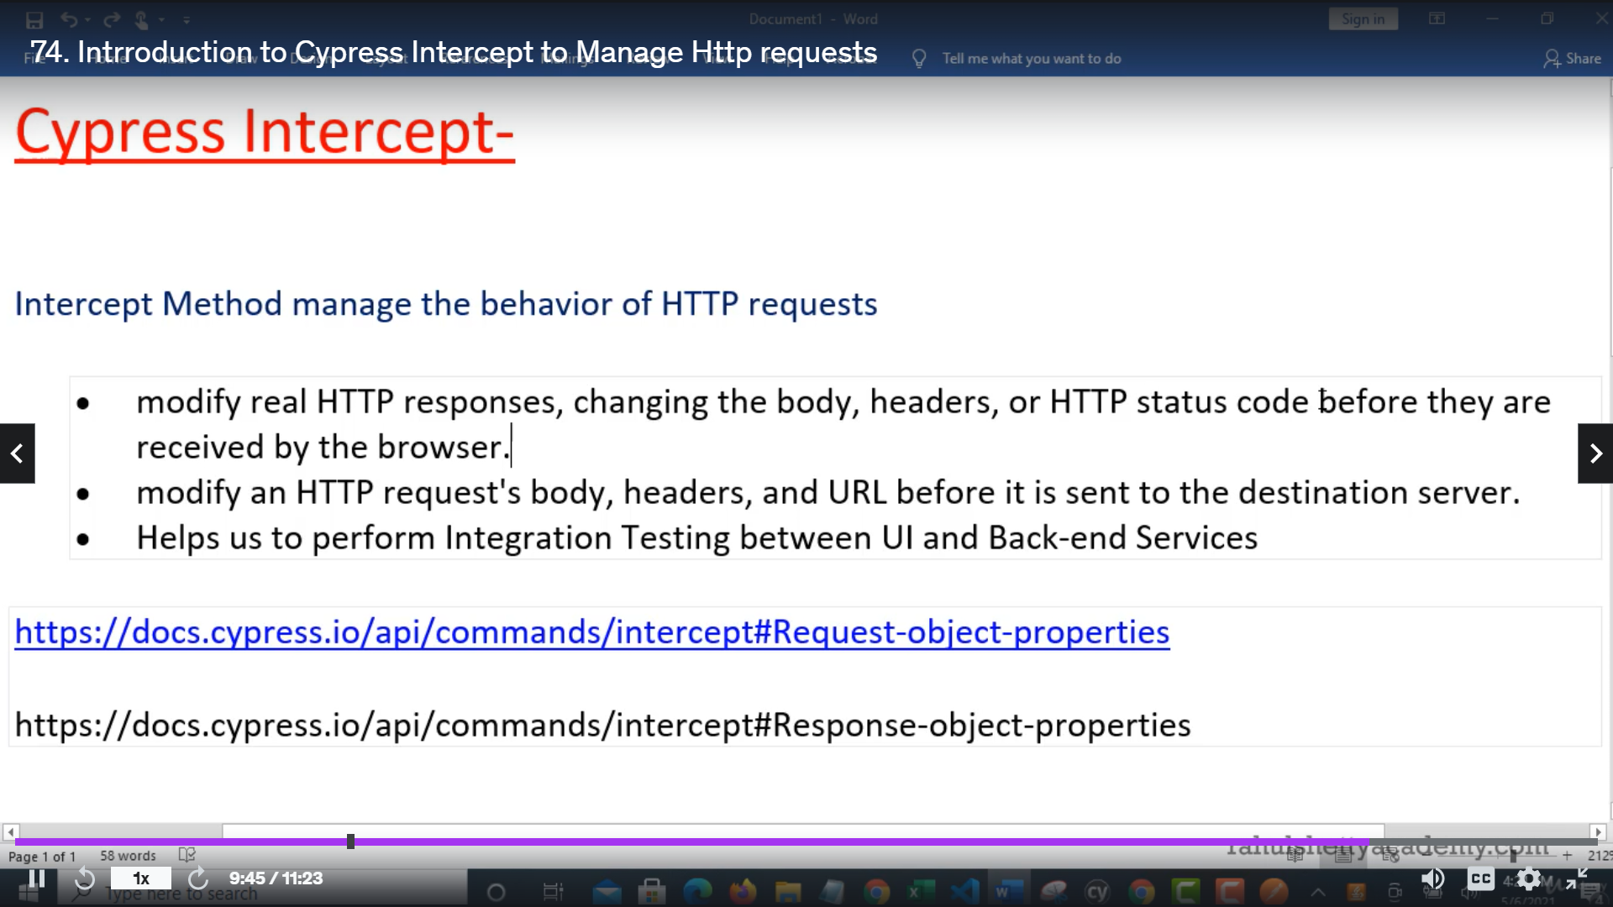
* **Cypress intercept:** [**https://docs.cypress.io/api/commands/intercept**](https://docs.cypress.io/api/commands/intercept)

-cy.intercept():

// spying only

cy.intercept(url)

cy.intercept(method, url)

cy.intercept(routeMatcher)

// spying and response stubbing

cy.intercept(url, staticResponse)

cy.intercept(method, url, staticResponse)

cy.intercept(routeMatcher, staticResponse)

cy.intercept(url, routeMatcher, staticResponse)

// spying, dynamic stubbing, request modification, etc.

cy.intercept(url, routeHandler)

cy.intercept(method, url, routeHandler)

cy.intercept(routeMatcher, routeHandler)

cy.intercept(url, routeMatcher, routeHandler)

practice site: https://rahulshettyacademy.com/angularAppdemo/library

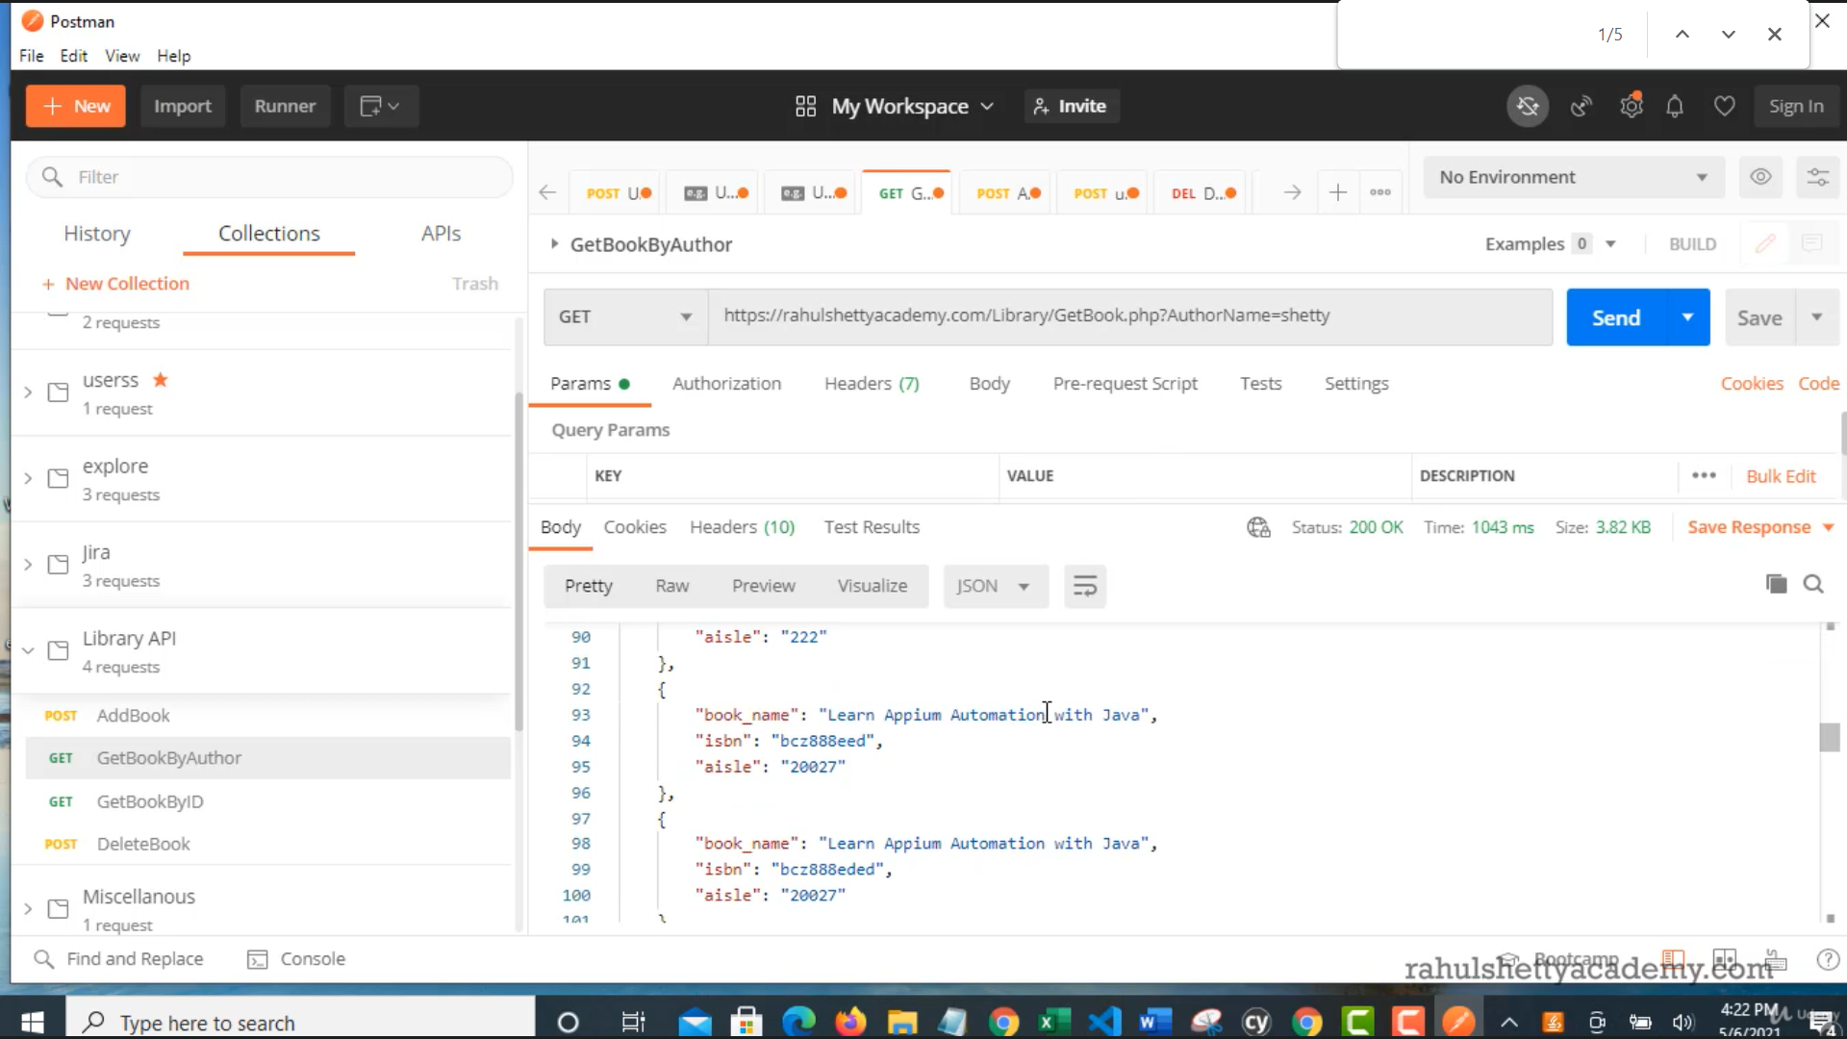

**Integration testing btwn front end and Backend:**

APIResponseValidation.js

**Intercepting HTTP requests to test Security scenarios:**

**Ex:** If u hit the site with diff user, API should send 403 forbidden status and should not show books on the page.

**APIRequestIntercepttest.js**

**API testing(Handling API call directly without involving browser with Cypress):**

Cy.request(): <https://docs.cypress.io/api/commands/request>

cy.request(url)

cy.request(url, body)

cy.request(method, url)

cy.request(method, url, body)

cy.request(options)

Sample resource to implement API testing:

**Library API :**

BaseURI : http://216.10.245.166

1. **Resource** : Library/Addbook.php       **Method** : POST

**Input Payload : Json**:

{

"name":"Learn Appium Automation with Java",

"isbn":"bcd",

"aisle":"227",

"author":"John foe"

}

**Output Json**

{

"Msg": "successfully added",

"ID": "bcd227"

}

-We can even do API automation also with Cypress. Ex: APIPureAutomation.js. But its not recommended to use Cypress to work on full Api automation testing. Tools like Rest assured or testNG is suggested

**How to Automate SSO in cypress:**

Cypress doesn’t allow u to switch to different domains from a test but it allows switching to subdomains.

For ex:

Cy.visit(‘www.apple.com’);

Cy.visit(‘google.com’); --🡪 throw error here

Cy.visit(‘www.cypress.io’)

Cy.visit(‘www.docs.cypress.io’)-🡪 it works here as it is a sub domain

Resource to implement SSO automation:

Please download the Demo App zip file from this lecture which we will be using in this section to practice

Unzip the downloaded file and import into visual Studio and run **npm install** command to download dependencies

**Authentication Server API Contract Details: -**

**url** – http://localhost:7075/login?redirectTo=http://localhost:7074/set_token

**Method**: POST

**url encoded Body content**

username : jane.lane

password : password123



**Storing JWT session token into browser local storage:**